StormDrive Instructions

# Initialization

Once you have deployed the .war file into you tomcat, navigate to <http://localhost:8080/COMP9323/testoauth.jsp>

You will see this message:

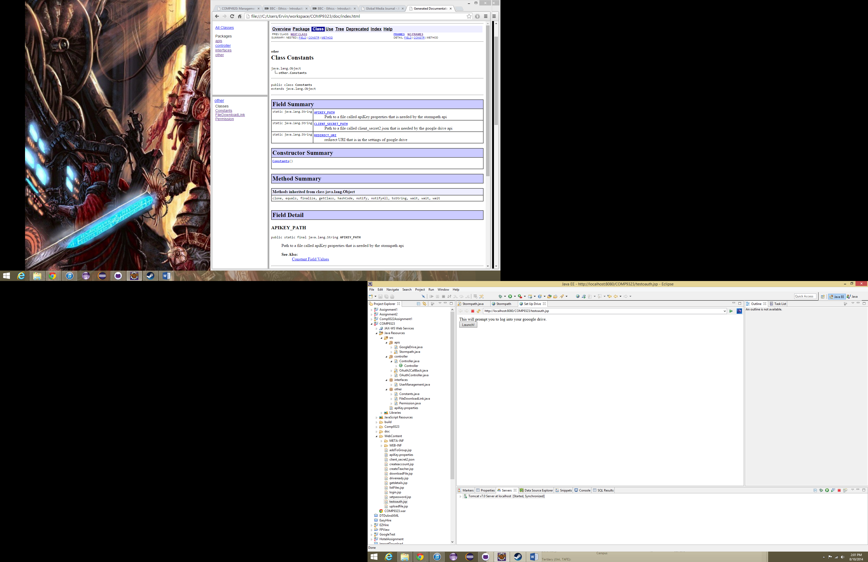

Click launch and this will prompt you to log into any google account.

Once you have successfully logged in you will see this message.

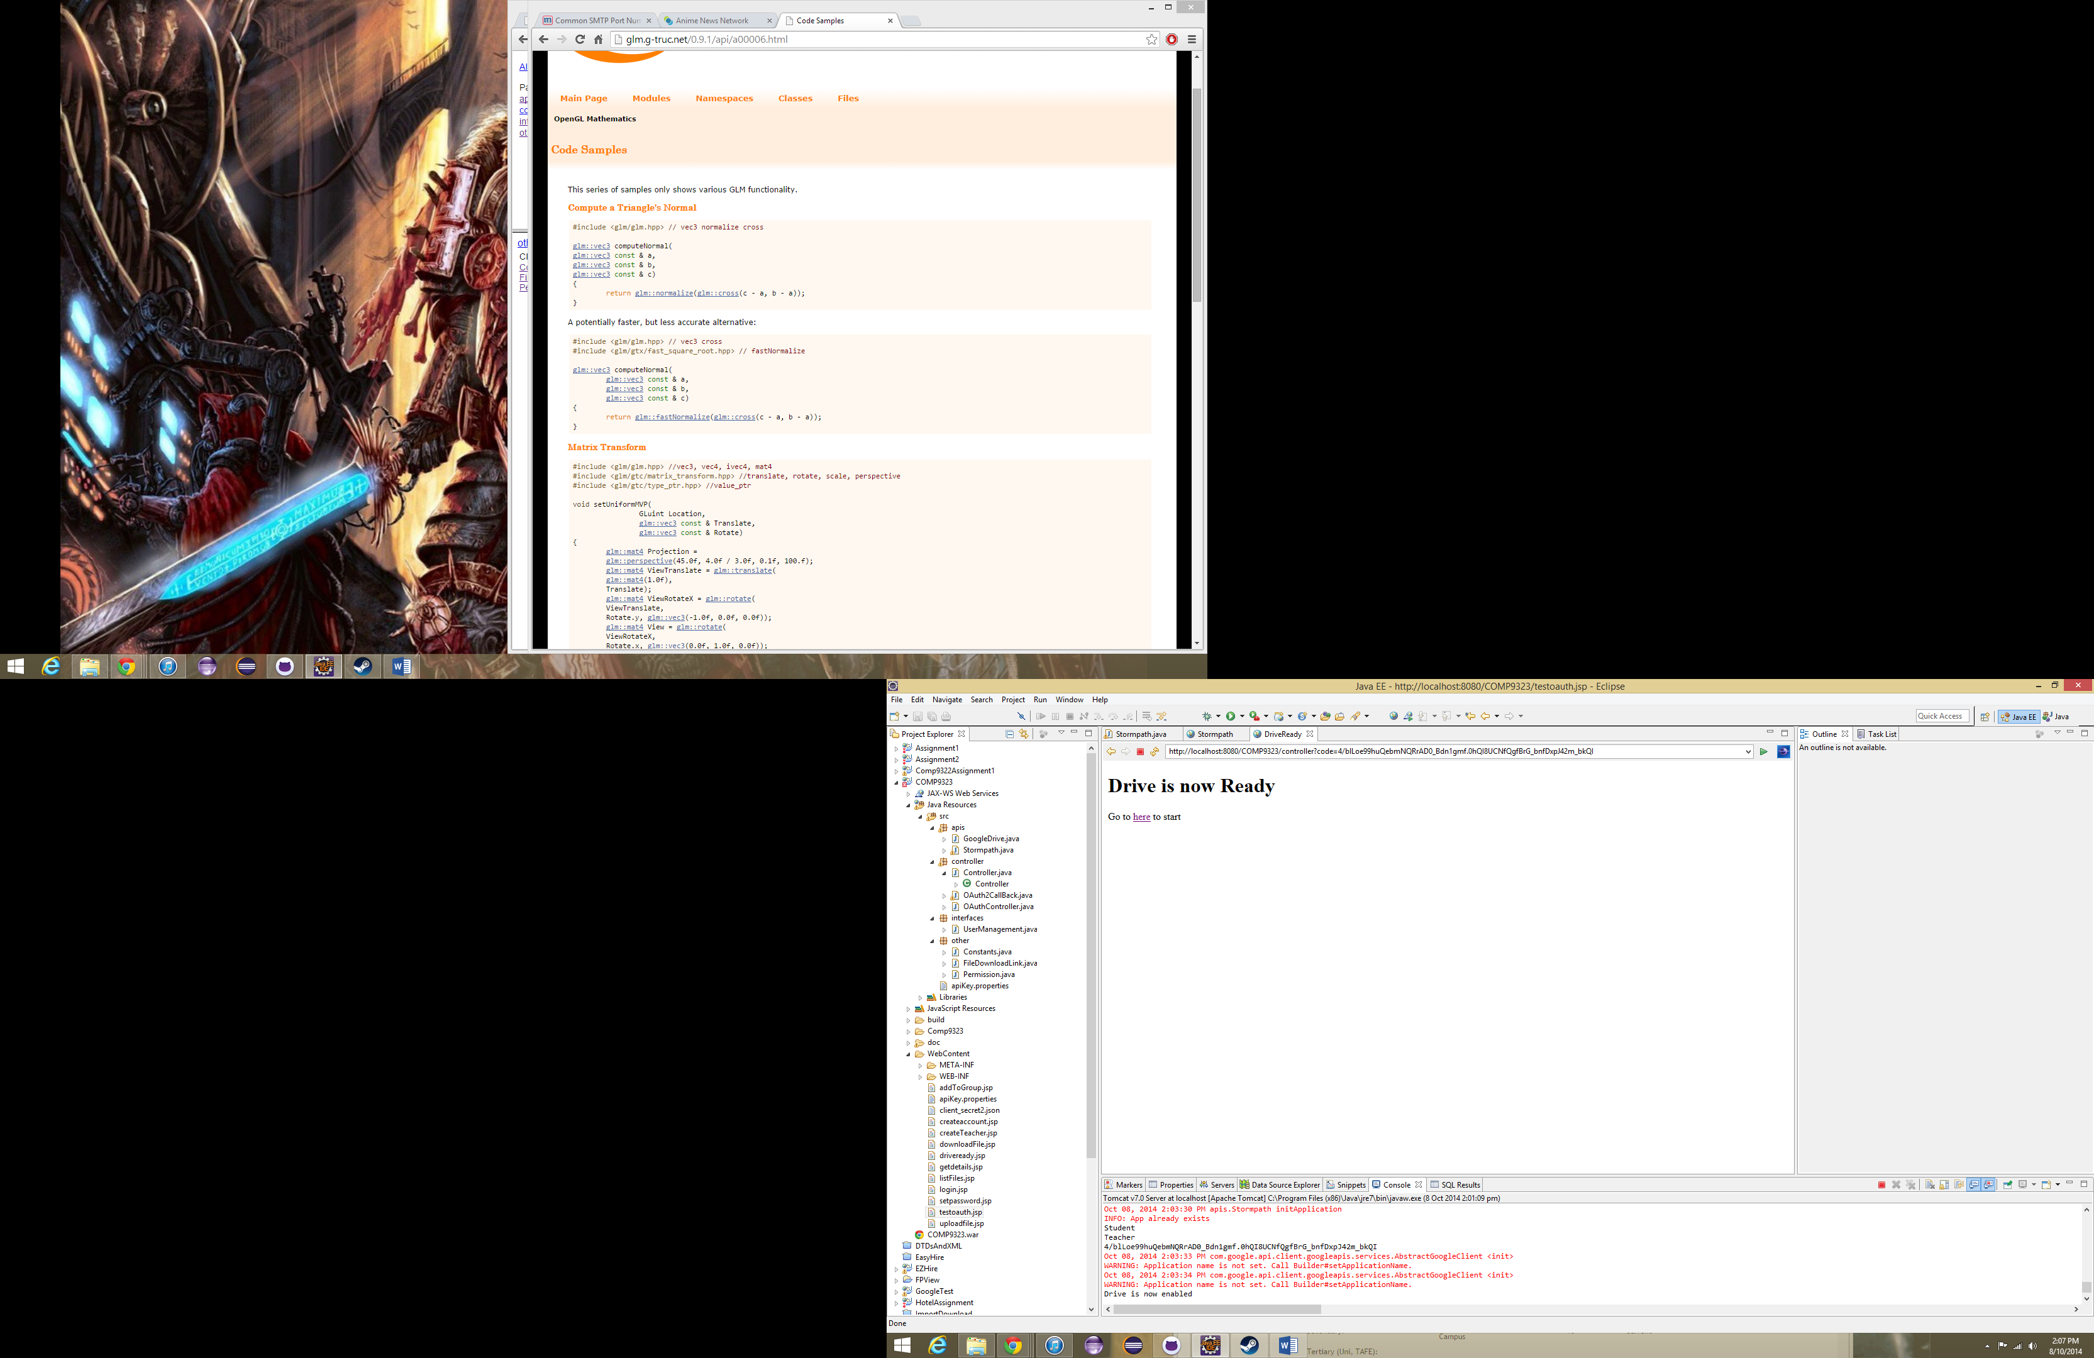

Once this has been done, it won’t have to be done again unless the server shuts down.

# Creating an account and logging in

Go to <http://localhost:8080/COMP9323/login.jsp>. If you don’t have an account click register to make one. Once you have created an account you can log in.

# Uploading a file

Once you are logged in, you can upload a file by going to <http://localhost:8080/COMP9323/uploadfile.jsp>

# Getting the download links in the directory

Navigate to <http://localhost:8080/COMP9323/listFiles.jsp> and click view to get the download links.

# Known issues

* No data about who submitted the file has been recorded
* Files inside a folder cannot be listed yet

# Software Architecture

## View

addToGroup.jsp

createaccount.jsp

downloadFile.jsp

createTeacher.jsp

driveready.jsp

login.jsp

listFiles.jsp

getdetails.jsp

setpassword.jsp

testoath.jsp

logout.jsp

uploadfile.jsp

## Controller

OAuthController

Controller

Authorization

UserManagement

Storage

## Model

Google Api

Stormpath Api

## Key

JSP

Controller class

Interface

API Access class